

**ATOM 2**

**FALL CLASSIC**

**Hockey Tournament**

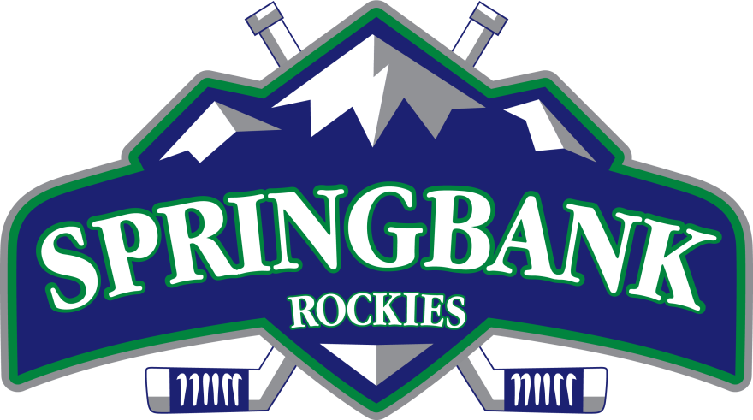

**www.SpringbankHockey.com**



**November 25-27**

**Calgary, AB**

