BOW RIVER
BRUINS
WHITEMUD WEST

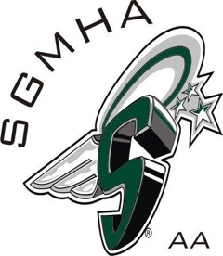
SPRUCE GROVE
SAINTS

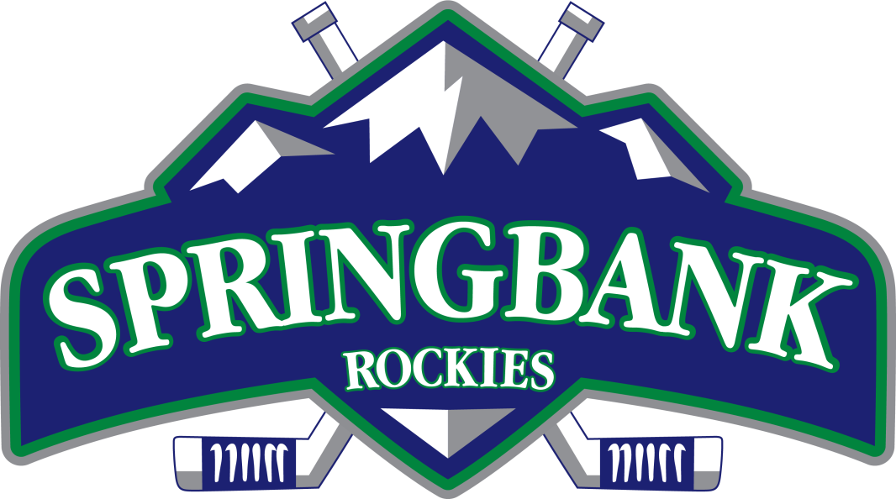
SPRINGBANK
ROCKIES

